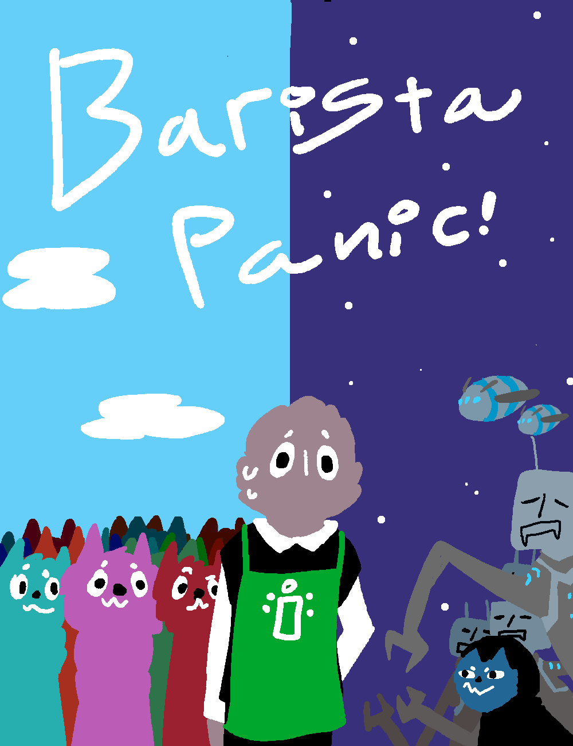

# 

# Barista Panic!

*Document Version 1.3*

*Written by KattSkratch*

*Point of contact: Roman Gunn (360) 688 3604*

*Version number: 3.4*

**Game Goals** -- Maintain a cafe business, upgrade your arsenal, defend your cafe shop, keep a good reputation from the newsletter headlines, and become the best barista of them all.

* **Game’s “high concept”** -- Barista Panic! is an action-packed top down shooter hybrid with a rhythm inspired minigame. You serve coffee to the Katts at day, and defend your cafe from other-worldly invaders at night. From the money you received during the day, you can buy upgrades for your arsenal from the shop.
* **Who, What, How?**
  + **Who** -- General audience ages 15 and up, the ESRB rating would be everyone 10 and up.
  + **What** -- You start the game working at a cafe and earn money by serving the Katt through a combination of arrows you need to match. After you close shop you can upgrade a variety of weapons to defend your cafe shop from invaders such as robots operated by aliens, evil Katts, and more.
  + **How** -- Endless gameplay with top down shooter mechanics. Has rhythm gameplay for other audiences, the mechanics mesh well leading into each other seamlessly. Hand-drawn, unique looking art assets. Certain enemies drop power ups that you can use to boost your attacks via explosions, attack speed, or slowing enemies down.
* Platforms: Windows, Mac, Linux
* Mode: Single-player
* The daytime segment contains a rhythm-esque minigame where the Katts come up to order their coffee, you get an array of 4 or more arrows that you need to follow to earn money. The nighttime segment includes a top-down shooter that you shoot the incoming enemies that race towards your desk to steal your bean of power.

**Story Overview**

In the planned story mode, Mr Candlesmith (The player) owns a coffee shop powered by an ancient relic known as the power bean. As you play, Mr Candlesmith’s cafe shop will continue to grow as you earn more and more money. At night, Candlesmith’s shop will come under attack from invaders that aim to take his power bean.

The player will automatically be moved throughout the chapters from one scene to the next, to come back and play past chapters you can select them from the menu after you have completed them. In the finale, you will be confronted by the king of the aliens that wields all the relics to make the power coffee. As he sips the ancient brew, you must engage in one final conflict for all of kat-kind and the universe.

* This story will be told in-game through a use of dialogue.

**Game Controls**

*Day-time*

Arrow Keys/WASD - Enter a order input

*Night-time*

WASD - Move

Move Mouse - Aims the player at the mouse

Left Click - Uses the weapon bound to the left mouse button

Right Click - Uses the weapon bound to the right mouse button

Q - Uses the item bound to the Q button

E - Uses the item bound to the E button

Middle Mouse Button Click - Uses the special bean that is currently selected.

**Technological requirements**

* Engine: Unity
* Scripting: Visual Studios (C#)
* Visual Graphics: Krita
* Cheats:
  + Left Bracket - Gives you $20 at a time at the shop.
  + 1 - Reduces time remaining on the day-time and night-time by 5 seconds.
  + 0 - Gives you an Ice Bean
  + Minus - Gives you an Explosion Bean
  + Plus - Gives you a Greasy Bean
* System Requirements
  + Processor: Intel Pentium 2.0 GHz or higher
  + Memory: 1024 MB RAM
  + Graphics: Direct3D compatible video card with 128MB memory or more.
  + Storage: N/A
  + Sound Card: DirectSound compatible sound card.

**Font end of the game**

* “Made with Unity” logo

**Attract mode description** -- Menu changes from day to night as you leave it be.

**Title/Start Screen**

* An image of the title/start screen and any associated animation and graphics.
* Selection Options:
  + Continue Game
  + Start Game
  + Exit Game
  + Options
  + Tutorial
* Save/load file -- The game file will be saved when you complete a full loop through the day and night automatically. Reload the file by either pressing “Continue” at the end of the night or press “Continue Game” on the start menu.
* Player options:
  + Select Fullscreen
  + Volume
  + Maybe Alternate Controls (N/A)

**Game Camera(s)**

* 2D camera with all the characters facing the camera at an angle during the daytime.
* Top-down camera during the night time.

**HUD System**

*Day-Time*

Day Timer - Represents how long until the day-time minigame is over. This is represented through text.

Money Earned - Tells you how much you earned that day. This is represented through text

*Shop*

Total Money - All the money that you have earned from the previous days and the day prior. This is represented through text.

Tooltips - Provides a short description of the item you’re hovering your mouse over. This is represented through text.

*Night-Time*

Objective Lives - Represents how many more hits your desk can take. This is represented through sprites

Time Remaining - Tells the player how much more time they have until the night shift is done. This is represented through text.

Gear Hotbar - Tells the player what weapons/items are bound to which keys. This is represented through a combination of text and sprites.

Power-up Bean Box - Tells the player which power up bean they are currently selecting. This is represented through a combination of text and sprites.

**Player Character(s)**

Mr. Candlesmith is a cafe owner of “Candlesmith Cafe”, he has come into contact with the power bean and protects it from evil.

Relationships:

Katts - He serves coffee to the katts.

Kattnip News - The news headlines that reports on businesses.

Invaders/Kultists - Attempting to steal the power bean from Candlesmith.

**Player Skills** —

* Armor
* HP Fill
* Speed
* Revolver
* Shotgun
* Grenade
* Rapid-fire
* Shield

**Player Inventory Tools (Equipment, spells, buffs, and so on)** — You obtain weapons and abilities from the shop that you use. Before you start the night you select what abilities and weapons to bring with you and what key to bind them to. Depending on the weapon you have currently equipped, it’ll change the way your weapon fires and how long you need to wait between firing.

**Combat** --

* Ranged
  + Revolver
    - A mid-long ranged weapon that shoots a single bullet that packs a punch. It might be difficult to hit for some but it has very good damage.
  + Grenade
    - A close-mid ranged weapon that throws out a grenade before exploding into an area of effect.
  + Rapid Fire
    - A mid ranged weapon that shoots a volley of bullets that don’t do much by itself but does a lot of damage as you put more bullets into him.
  + Shotgun
    - A close ranged weapon that shoots three bullets, by themself it doesn’t really do well, but if you hit all three bullets into the enemy it sure adds up!
* Upgrades
  + These weapons increases in damage as you buy more tiers of the weapons in the shop.

**Power-ups/state modifiers**

* Speed up
  + Speeds up the player to a certain speed depending on how upgraded you are in the shop for five seconds.
* Armor
  + Gives the player disposable armor that gets destroyed before the player’s health gets affected.
* HP Fill
  + Returns some health depending on how powerful it is from the shop.
* Elemental Beans
  + These beans affect your weapons for a certain amount of time:
  + Greasy Bean
    - Increases your firing speed and reduces the time between shooting and reloading.
  + Explosion Bean
    - Adds an explosion after you hit a bullet to do AoE damage.
  + Ice Bean
    - Slows down enemies upon hitting them with the bullet.

**Rewards and economy** -- The game’s monetary system has the cash earned through the day-time minigame by completing order for the Katts. You use this money to spend it on upgrades to weapons and/or to buy a weapon or power-up. You can save this money simply by just advancing to the next night and completing the night-time. The shop interface has a series of buttons that when you hover over one, it tells you all the tiers of the weapon you can buy.

**Collectibles/Object Sets** --

* Elemental Beans
  + Greasy Bean
  + Explosion Bean
  + Ice Bean
* Weapons
  + Rapid Fire
  + Shotgun
  + Revolver
  + Grenade
  + HP Fill
  + Speed
  + Armor
  + Shield

**Universal game mechanics** -- List mechanics that will be found throughout the game. Always include images of each mechanic.List each platform, portal, breakable, hazard, interactable object, and puzzle element and how the player interacts with them.

* *Pick-ups*
  + Elemental Beans
* *Mini-game Mechanics*
  + Repeat the arrow keys that display above the Katt in the correct order to receive money.

**General Enemy Rules**

* Melee Enemy
  + Runs towards the objective and then quickly turns around to attack the player if they get close enough.
* Ranged Enemy
  + Stands still and shoots at the player, when the player approached the enemy, they run away.
* Special Enemies
  + Bean-liner
    - Run straight towards the desk objective.
    - When killed, drops an elemental bean.
  + Kultist
    - Pounces on the player from a distance.
    - Runs towards a bean that was dropped.
    - Uses the bean to fight you.

**NPCs**

*Mr. Candlesmith*

**

The sweet barista shop owner who sells coffee to the Katts.

*Katts*

**

The cat-like creatures that live in the city and love to come to Candlesmith’s shop for a hot cup of coffee.

*Kultists*

**

Hooded Katts that are against Mr. Candlesmith’s Cafe business and wants to work with the robots at night to help their pursue in taking over the universe. They get angered after their order is done completely wrong by the player/Mr. Candlesmith.

**Minigames** -- List the types of minigames and provide illustrations showing each game type. Describe how to play and use control schemes. List what original and repurposed game elements the minigames require. List what levels the games are found on and what rewards they yield.

The minigame that we have in the game is also the main way to earn money, how nifty! You do a rhythm inspired based game where arrow keys show up on the top of the screen and you press the corresponding keys with the arrow keys or with WASD. This minigame is played in every core loop.

**Downloadable Content** -- Current DLCs planned is extra chapters off the main story

**Music and SFX** -- List all music needs. Describe the tone or feeling of each piece. List on what level the music is needed, and don’t forget the title, pause, and option screens as well as end credits.

*Music*

* Day-time
  + Jazzy upbeat song
* Shop
  + Jazzy normal song
* Night time
  + Neutral chaotic jazz

*Sound Effects*

* Day-time
  + Bell ring
  + Mr. Candlesmith talking
  + Katts talking
* Shop
  + Spend money
* Night-time
  + Shoot weapon